Proposed Joint British Societies Cardiovascular Disease
Risk Prediction Chart
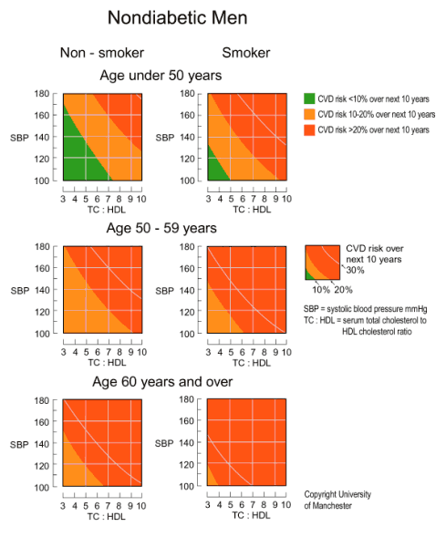
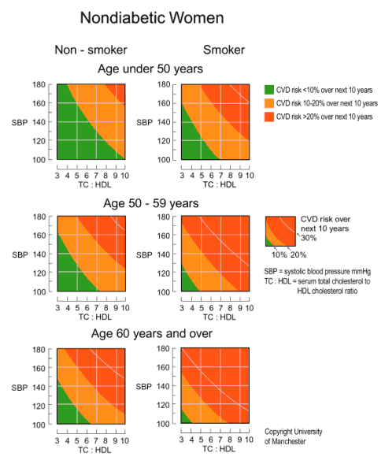
Cardiovascular Disease Risk Prediction Chart reproduced with permission from The University of Manchester Department of Medical Illustration, Manchester Infirmary
How to use the Cardiovascular Disease Risk Prediction Charts for Primary Prevention
These charts are for estimating cardiovascular disease (CVD) risk (non-fatal myocardial infarction [MI] and stroke, coronary and stroke death and new angina pectoris) for individuals who have not already developed coronary heart disease (CHD) or other major atherosclerotic disease. They are an aid to making clinical decisions about how intensively to intervene on lifestyle and whether to use antihypertensive, lipid lowering medication and aspirin.
- The use of these charts is not appropriate for the following patients groups. Those with:
  - CHD or other major atherosclerotic disease
  - Familial hypercholesterolaemia or other inherited dyslipidaemias
  - Chronic renal dysfunction
  - Type 1 and 2 diabetes mellitus
- The charts should not be used to decide whether to introduce antihypertensive medication when blood pressure (BP) is persistently at or above 160/100 or when target organ damage (TOD) due to hypertension is present. In both cases antihypertensive medication is recommended regardless of CVD risk. Similarly the charts should not be used to decide whether to introduce lipid-lowering medication when the ratio of serum total to high density lipoprotein (HDL) cholesterol exceeds 7. Such medication is generally then indicated regardless of estimated CVD risk.
- To estimate an individual's absolute 10 year risk of developing CVD choose the table for his or her gender, smoking status (smoker/non-smoker) and age. Within this square define the level of risk according to the point where the coordinates for systolic blood pressure (SBP) and the ratio of total cholesterol to HDL-cholesterol meet. If no HDL cholesterol result is available, then assume this is 1.00mmol/l and the lipid scale can be used for total serum cholesterol alone.
- Higher risk individuals (red areas) are defined as those whose 10 year CVD risk exceeds 20%, which is approximately equivalent to the CHD risk of >15% over the same period indicated by the previous version of these charts. As a minimum those at highest CVD risk (greater than 30% shown by the line within the red area) should be targeted and treated now. When resources allow, others with a CVD risk of >20% should be progressively targeted.
- The chart also assists in the identification of individuals whose 10 year CVD risk moderately increased in the range 10-20% (orange area) and those in whom risk is lower than 10% over 10 years (green area).
- Smoking status should reflect lifetime exposure to tobacco and not simply tobacco use at the time of assessment. For example, those who have given up smoking within 5 years should be regarded as current smokers for the purposes of the charts.
- The initial BP and the first random (non-fasting) total cholesterol and HDL cholesterol can be used to estimate an individual's risk. However, the decision on using drug therapy should generally be based on repeat risk factor measurements over a period of time.
- Men and women do not reach the level of risk predicted by the charts for the three age bands until they reach the ages 49, 59, and 69 years respectively. Everyone aged 70 years and over should be considered at higher risk. The charts will overestimate current risk most in the under forties. Clinical judgement must be exercised in deciding on treatment in younger patients. However, it should be recognised that BP and cholesterol tend to rise most and HDL cholesterol to decline most in younger people already possessing adverse levels. Thus untreated, their risk at the age 49 years is likely to be higher than the projected risk shown on the age-less-than 50 years chart.
- These charts (and all other currently available methods of CVD risk prediction) are based on groups of people with untreated levels of BP, total cholesterol and HDL cholesterol. In patients already receiving antihypertensive therapy in whom the decision is to be made about whether to introduce lipid-lowering medication or vice versa the charts can act as a guide, but unless recent pre-treatment risk factor values are available it is generally safest to assume that CVD risk is higher than that predicted by current levels of BP or lipids on treatment.
- CVD risk is also higher than indicated in the charts for:-
  - Those with a family history of premature CVD or stroke (male first degree relatives aged <55 years and female first degree relatives aged <65 years) which increases the risk by a factor of approximately 1.5
  - Those with raised triglyceride levels
  - Women with premature menopause
  - Those who are not yet diabetic, but have impaired fasting glucose (6.1-6.9mmol/l)
- In some ethnic minorities the risk charts underestimate CVD risk, because they have not been validated in these populations. For example, in people originating from the Indian subcontinent it is safest to assume that the CVD risk is higher than predicted from the charts (1.5 times).
- The charts may be used to illustrate the direction of impact of risk factor intervention on estimated level of CVD risk. However, such estimates are crude and are not based on randomised trial evidence. Nevertheless, this approach maybe helpful in motivating appropriate intervention. The charts are primarily to assist in directing intervention to those who typically stand to benefit most.

